15.11.2021г. группа 1ТЭМ 2 подгруппа 4 пара
Дисциплина ОДБ.03 Иностранный язык
Преподаватель Романюта Маргарита Вадимовна
Занятие № 20
Модуль 7 « LET’S HAVE FUN »
Тема 7.1. Современная молодежь. Виды представлений
Цели:
• Образовательная – расширение эрудиции студентов, их общего и лингвистического кругозора на основе практического овладения английским языком;
• Практическая–
1. Развитие навыков чтения, устной речи.
2. Совершенствование коммуникативно-познавательной компетенции студентов по теме «Современная молодежь. Виды представлений».
• Развивающая – развитие языковых, интеллектуальных и познавательных способностей студентов.
• Воспитательная – воспитание внимательного отношения к своему здоровью, привитие навыков здорового образа жизни, формирование общей культуры студентов.
Используемая литература:
1. Афанасьева О.В., Дули Дж., Михеева И.В., Оби Б., Эванс В. УМК «Английский в фокусе» для 10 класса, М.: Просвещение; UK.: Express Publishing: 2018;
2. Агабекян И. П., Коваленко П. И. Английский для технических вузов. Феникс, Ростов-на/Д, 2019.
Дополнительные источники:
- Ионина И., Саакян А. Английская грамматика. Теория и практика. – М.: Академия, 2018.
- Бережная О. О. Сборник новых тем современного английского языка. Донецк, 2019.
Справочники:
- Мюллер В. К. Англо-русский и русско-английский словарь. – М.: ЭКСМО, 2016.
Интернет-ресурсы:
- Портал по изучению английского языка.
Форма доступа: http//www.englishlanguage.ru.
- Сайты для изучения английского языка.
Форма доступа: http://www. study.ru – English Info
http://www.native-english.ru
http://www.study.ru
http://www.homeenglish.ru
1.Работа с лексикой
1.1.Прочитайте слова в словаре WL 21-22 .
1.2.Запишите в тетрадь слова с транскрипцией.
1.3. Look at the picture. What do you think 'square-eyed generation' means? Do you think this describes today's teens?

2.Работа с текстом на стр. 122.

2.1. Read and translate the text «A square-eyed generation ».
A square-eyed generation
In the UK, teenagers watch 2 to 3 hours of TV per day, video games are played by a third of 13-year-olds every day and 75% of 5 to 16-year-olds have their own TV. What about teenagers in your country? Are they turning into anti-social, square-eyed couch potatoes? What other forms of entertainment do they enjoy? Let’s see what some teens from around the world had to say!

“I think it’s totally unfair to label today’s teenagers as ‘the square-eyed generation’. Sure, I like to unwind on a Friday night with a good DVD, but one of my favourite things to do is go dancing at the famous London club ‘Ministry of Sound.’ You just can’t beat the atmosphere when the music’s blaring and everybody’s dancing!” Suzy, 18, UK
“To be honest, a lot of Mexican teenagers do spend too much time watching TV. Teenage soap operas or ‘telenovelas’ like ‘Rebelde’ have become really popular in recent years. The theme tunes in particular are usually really catchy! Members of the cast from these soaps sometimes even go on to record albums and become music stars!” Maria, 15, Mexico
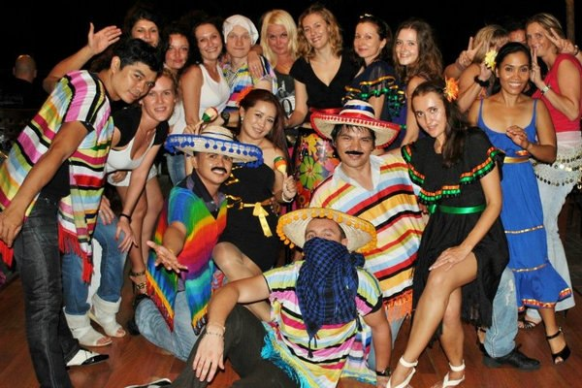
“I have my own TV in my room, but my favourite thing to do is to go out to ‘karaoke’ with my friends. Most Japanese teenagers love karaoke. We rent a special room where we can sing along to all the latest music. It’s such a good laugh!” Yoko, 17, Japan
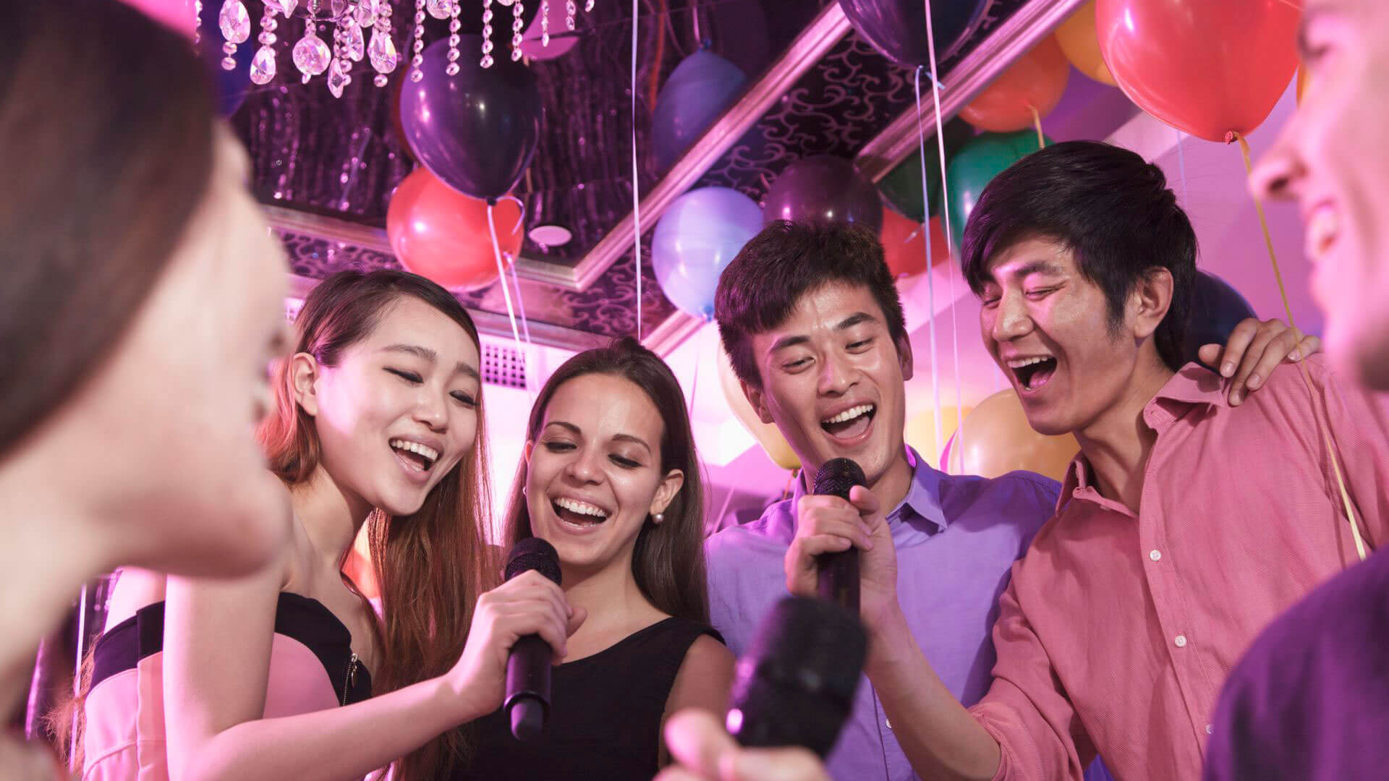
“Indian TV is OK, but I can take it or leave it. I prefer to go to the cinema to see ‘Bollywood’’ movies made by Indian directors. Bollywood movies are more like musicals really, with lots of singing, dancing and quite predictable storylines about things like love and family relationships. The Indian film industry now makes twice as many films as Hollywood you know!” Sanjit, 16, India
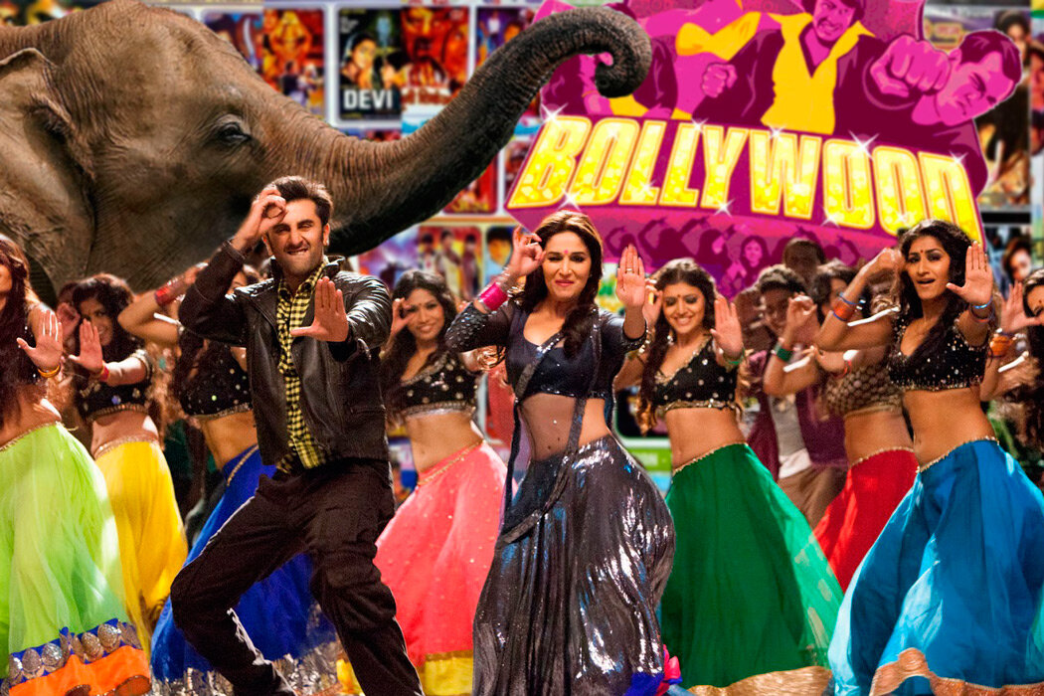
“I have to admit that I’m a bit of a video game addict. The graphics are incredible these days! I also like going to malls with my friends. I think it’s the best place to see and be seen, not just a place to spend money as many say.” Anya, 18, Russia

2.2. Read the teenagers' comments in the text on pp. 122-123. Who:
1. says they aren't mad about something?
2. uses a certain form of entertainment as a way to relax?
3. enjoys something that many other young people to enjoy too?
4. mentions actors becoming famous for something else?
5. can't stop doing something?
2.3. Choose the correct word. Which form of entertainment is each sentence related to: TV programmes? theatre? cinema? books?
1 The Phantom of the Opera had a very large cast/musical.
2 You need to book/reserve in advance if you are going to attend a performance.
3 Plays are performed on screen/stage.
4 Have you seen Superman Returns? It got very good reviews/critics.
5 I don't really enjoy watching ones with subtitles/headings.
3.Грамматические упражнения.
3.1.Circle the correct word. Explain your choices.
1 The box office sold/were sold 15,000 tickets for the concert in an hour!
2 In Shakespeare's Romeo and Juliet, two teenagers from rival families fall/are fallen in love.
3 Millions of video games have sold/have been sold all over the world.
4 The film sets/is set in England in the 18th century.
5 The audience applauded/were applauded wildly at the end of the performance.
6 Before 1927, films used to make/be made without sound.
3.2. Fill in by or with where necessary.
1 This dish is made ....... four types of cheese.
2 Mickey Mouse was created ..... Walt Disney.
3 Lyn was given top marks for her essay ..... her teacher.
4 His desk was covered ..... papers .

Домашнее задание:
1.Письменно выполнить упражнения 3.1; 3.2данного занятия.
2. Prepare ten Yes-No questions about TV and other popular entertainment forms in your country. Write a paragraph reporting the results.
Срок выполнения задания до 22.11.2021.
Все работы выполнять в рабочих тетрадях, фотографировать и отправлять на адрес преподавателя Романюты М.В. rita.romanyuta@mail.ru

